**CNS LAB**

**Batch: B1**

**Assignment: 10**

**PRN No: 2020BTECS00006**

**Name: Samrat Vishwas Jadhav**

Aim: **To observe SSL/TLS (Secure Sockets Layer/ Transport Layer Security)in action. SSL/TLS is used to secure TCP connections, and it is widely used as part of the secure web: HTTPS is SSL over HTTP.**

2 STEP 1: Open a Trace you should use a supplied trace file trace-ssl.pcap.

File → Open → open from folder containing file.

3 STEP 2: Inspect the Trace

Now we are ready to look at the details of some SSL messages. To begin, enter and apply a display filter of ssl.This filter will help to simplify the display by showing only SSL and TLS messages. It will exclude other TCP segments that are part of the trace, such as Acks and connection open/close. Select a TLS message somewhere in the middle of your trace for the Info field reads Application Data, and expand its Secure Sockets Layer block(by

using triangular icon on left side). Application Data is a generic TLS message carrying

contents for the application, such as the web page. It is a good place for us to start looking at TLS messages. Look for the following protocol blocks and fields in the message

• The lower layer protocol blocks are TCP and IP because SSL runs on top of TCP/IP.

• The SSL layer contains a TLS Record Layer. This is the foundational sublayer

for TLS. All messages contain records. Expand this block to see its details.

• Each record starts with a Content Type field. This tells us what is in the contents

of the record. Then comes a Version identifier.It will be a constant value for the SSL

connection.

• It is followed by a Length field giving the length of the record.

• Last comes the contents of the record. Application Data records are sent after

SSL has secured the connection, so the contents will show up as encrypted data.

Note that, unlike other protocols we will see such as DNS, there may be multiple records in a single mes-sage. Each record will show up as its own block. Look at the Info column, and you will see messages with more than one block.

Answer the following questions to show your understanding of SSL records:

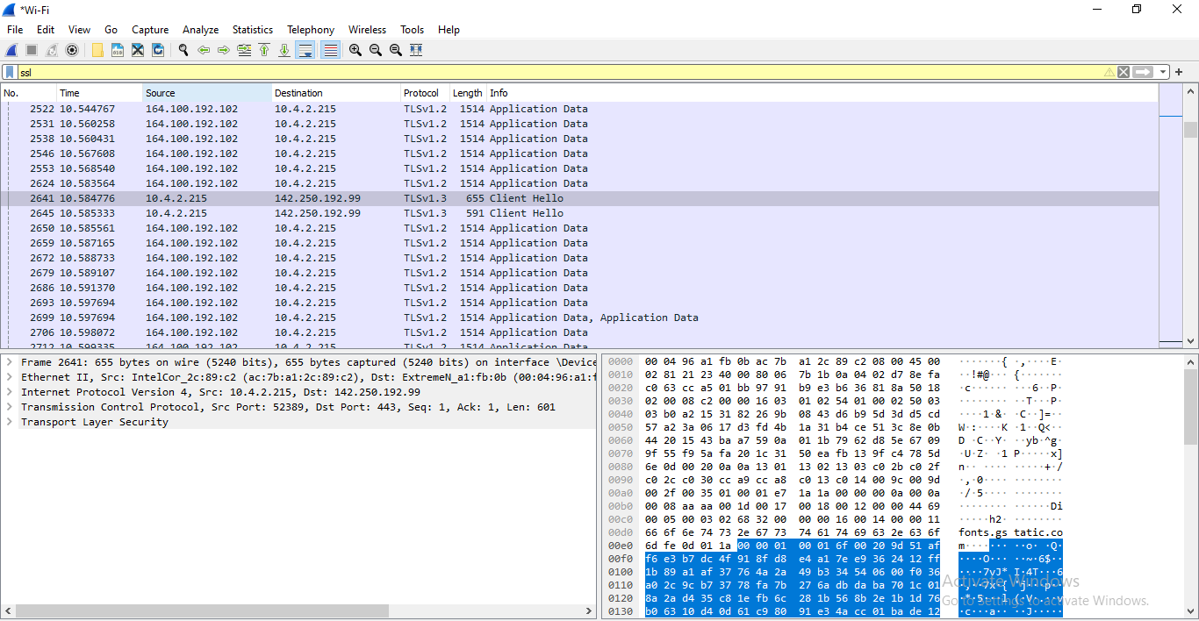

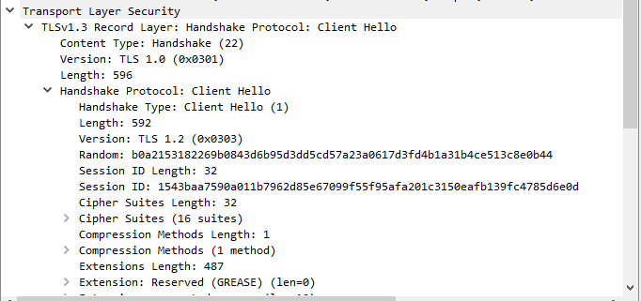

1. What is the Content Type for a record containing Application Data?:

Content Type: Handshake(22)

2. What version constant is used in your trace, and which version of TLS does it represent?

Version : 1.0 (0x0301)

4 Step 3: The SSL Handshake

An important part of SSL is the initial handshake that establishes a secure connection.

The handshake proceeds in several phases. There are slight differences for different

versions of TLS and depending on the encryption scheme that is in use. The usual outline

for a brand new connection is:

• Client (the browser) and Server(the web server) both send their Hellos

• Server sends its certificate to Client to authenticate (and optionally asks for Client

Certificate)

• Client sends keying information and signals a switch to encrypted data.

• Server signals a switch to encrypted data.

• Both Client and Server send encrypted data.

• An Alert is used to tell the other party that the connection is closing. Note that

there is also a mechanism to resume sessions for repeat connections between the same

client and server to skip most of steps b and c.

4.1 Hello Message

Find and inspect the details of the Client Hello and Server Hello messages, including

expanding the Hand- shake protocol block within the TLS Record. For these initial

messages, an encryption scheme is not yet established so the contents of the record are

visible to us. They contain details of the secure connection setup in a Handshake

protocol format.

Answer the following questions.

1. How long in bytes is the random data in the Hellos? Both the Client and Server

include this random data (a nonce) to allow the establishment of session keys.

→ Length of random Bytes: 28

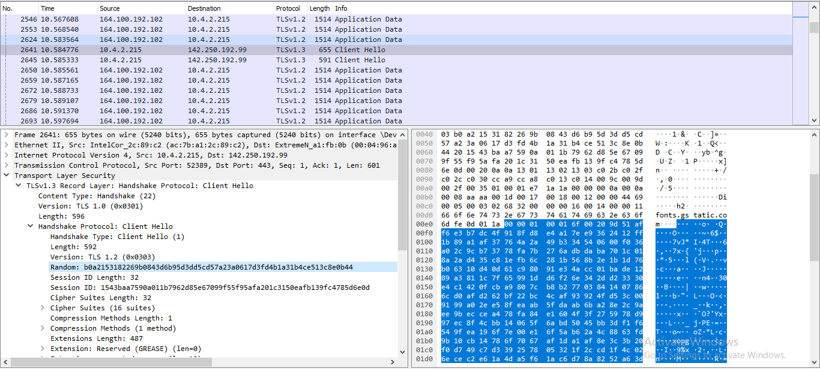

2. How long in bytes is the session identifier sent by the server? This identifier allows later resumption of the session with an abbreviated handshake when both the client and server indicate the same value. In our case, the client likely sent no session ID as there was nothing to resume.

→ Session Identifier Length: 32 (Bytes 110 - 141)

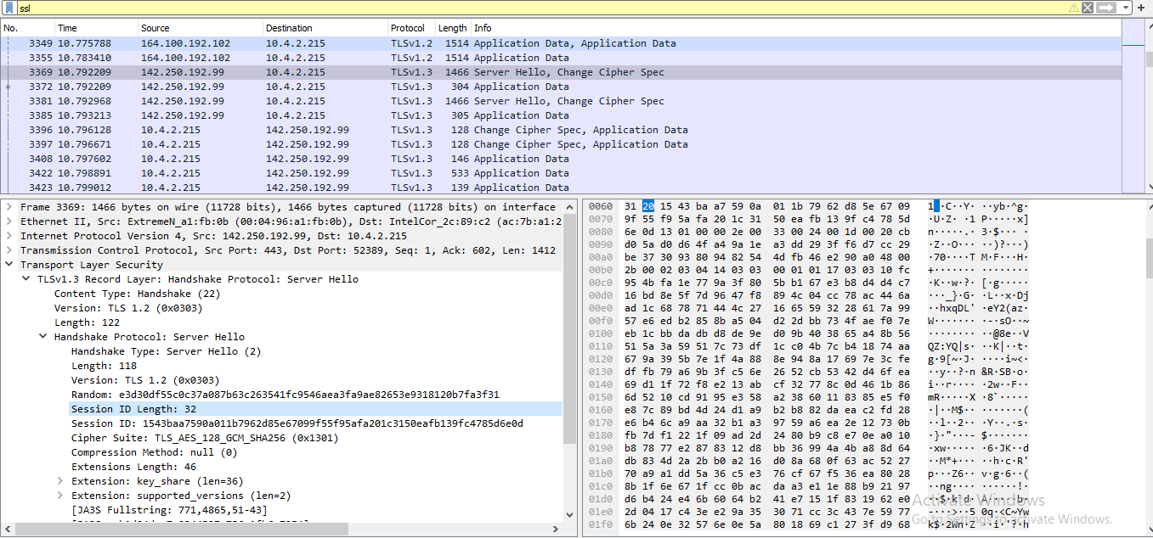

3. What Cipher suite is chosen by the Server? Give its name and value. The Client will list the different cipher methods it supports, and the Server will pick one of these methods to use.

→ Cipher Suite used by the Server is:

Cipher Suite: TLS_AES_128_GCM_SHA256 (0x1301)

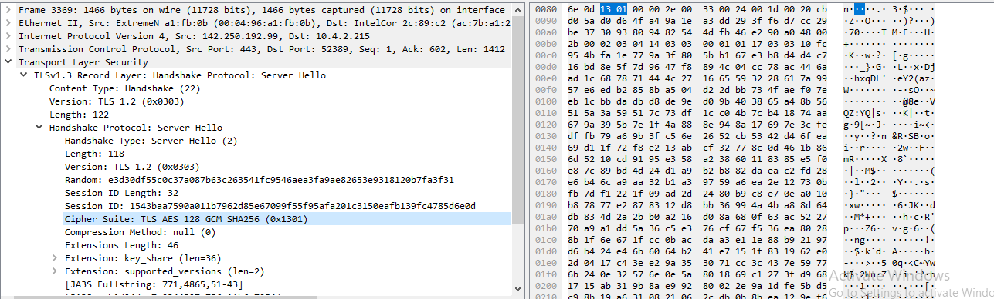

4.2 Certificate Messages

Next, find and inspect the details of the Certificate message, including expanding the Handshake proto-col block within the TLS Record. As with the Hellos, the contents of the Certificate message are visible because an encryption scheme is not yet established. It should come after the Hello messages.

Answer the following questions:

1. Who sends the Certificate, the client, the server, or both? A certificate is sent by one party to let the other party authenticate that it is who it claims to be. Based on this usage, you should be able to guess who sends the certificate and check the messages in your trace.

→ In this packet tract only server is sending its certificate. But there might be the

case that the server could ask the client to provide its own certificate for the

identity of the client.

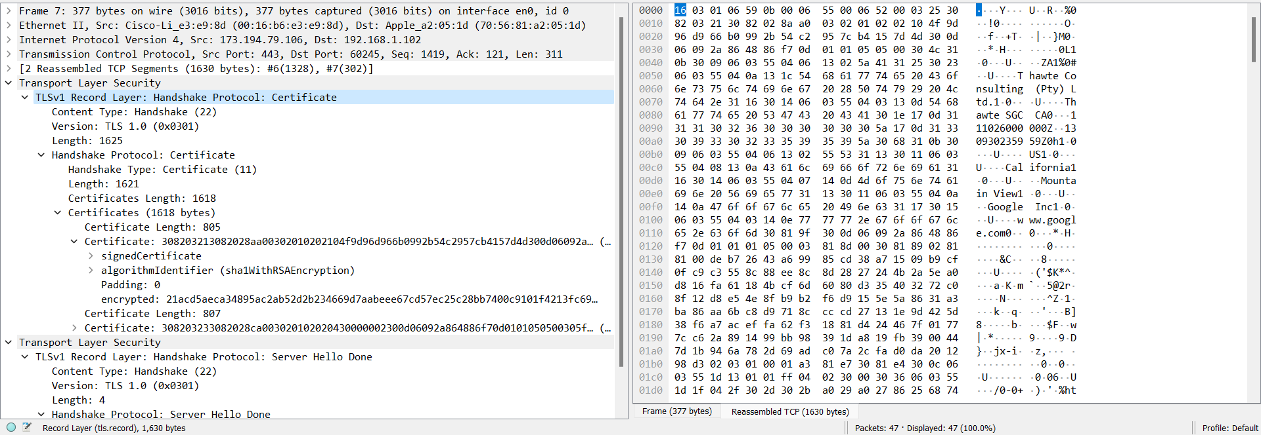

A Certificate message will contain one or more certificates, as needed for one party to verify the identity of the other party from its roots of trust certificates. You can inspect those certificates in your browser.

4.3 Client Key Exchange and Change Cipher Messages

Find and inspect the details of the Client Key Exchange and Change Cipher messages, expanding their various details. The key exchange message is sent to pass keying information so that both sides will have the same secret session key. The change cipher message signal a switch to a new encryption scheme to the other party. This means that it is the last unencrypted message sent by the party.

Answer the following questions:

1. Who sends the Change Cipher Spec message, the client, the server, or both?

→ The change cipher spec message is sent by both client and server. Client sent it first.

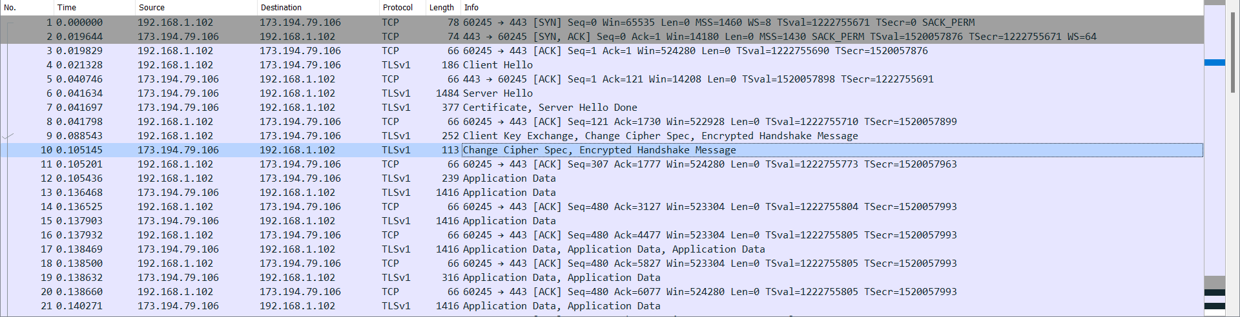

2. What are the contents carried inside the Change Cipher Spec message? Look past the Content Type and other headers to see the message itself.

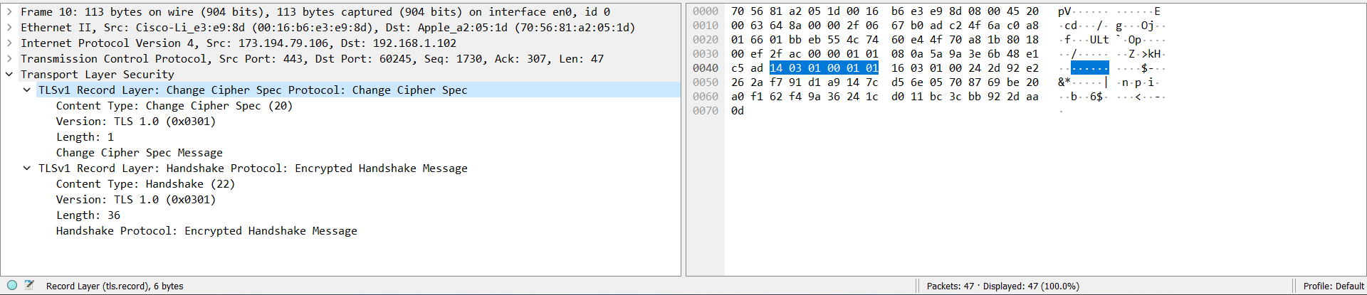

→ The Change Cipher Spec Message contains following Fiels:

● Content Type

● Version

● Length

● change cipher spec message